**PROJECT DOCUMENTATION**

**Title**: Global Electronics retail store (TMP Mart)

**Tables**:

Fact Table:

Customers – Customers Information/details

Products – Description of products sold in the store

Dim Table:

Sales – Inventory of sales in the store

Stores – Details of the stores across the globe

Exchange Rates – Currency information used in the store

**Project Objectives**:

Sales table:

1. What are the monthly and yearly sales trends?
2. Which products were the best sold across all stores?
3. Which customers were the top buyers?
4. Which currencies are most used in sales, and how do they impact revenue?
5. Are there seasonal spikes or dips in product demand?
6. Which stores or regions are the top and bottom performers in terms of sales and profitability?
7. How do monthly and quarterly sales trends vary across different Stores and Country?
8. What is the trend in Delivery Status for the orders made?
9. What is the item visibility in the stores and how it influences sales?

Customer table:

1. What is the gender and age distribution of our customer base?
2. Which states or cities contribute the most to sales?
3. What is the purchase frequency per customer?
4. Who are our most valuable (high-spending) customers?
5. How do customer demographics influence purchasing behavior and product preferences?
6. What is the average revenue per customer, and how does it vary by customer segment?
7. Age distribution by revenue.

Product table:

1. Which brands generate the highest profit margins?
2. How do unit costs compare to unit prices across product categories?
3. Which product categories perform best in terms of volume and revenue?
4. How do product colors or brands affect sales?
5. Which products and product categories are the most and least profitable?
6. Are there seasonal or geographic trends in product sales?
7. Which products are underperforming and should be reviewed or discontinued?

Store table:

1. Which stores generate the highest revenue and sales volume per square meter?
2. How does sales performance vary by country and state?
3. Is there a relationship between store size (square meters) and sales output/total revenue?
4. Are newer stores performing better than older ones?
5. Which stores have the highest sales per square meter?
6. Which regions or states have the highest concentration of top-performing stores?
7. How do store-level KPIs (like average transaction value or total orders) differ by location?
8. What is the store distribution by size, and how does it impact product assortment and sales?
9. Are there underperforming stores that may need operational review or marketing support?

Exchange Rate table:

1. How do exchange rate fluctuations affect international revenue?
2. What is the USD-equivalent value of revenue in other currencies?
3. Are there currencies that show better conversion efficiency (profitability)?
4. How have exchange rate trends changed over time?
5. Do sales in certain currencies correlate with market expansion or contraction?
6. How have fluctuations in exchange rates affected sales reporting and revenue comparisons?
7. Which currencies or countries contribute most to revenue volatility?
8. How does the timing of sales correlate with exchange rate trends?
9. Would normalizing sales in USD improve financial visibility for global operations?
10. What is the total revenue generated across all stores in local and USD currency?

**Data Cleaning**:

The data set was cleaned with Power BI power query.

1. Renamed columns
2. Changed data type – Square meter column from whole number to decimal number and Zip Code column in customers table to text.
3. Replace 1% null value in the store table with ‘0’
4. No changes were made for delivery date column that has 86% empty cells – Stores table.
5. Created a conditional column for delivery status based on delivery date.

**Data Analysis and Visualization**:

Data Analysis tool – Power BI

Data Modeling – Power BI automated the modeling, and I added a many-to-many relationship model for Exchange Rate Table and Sales Table.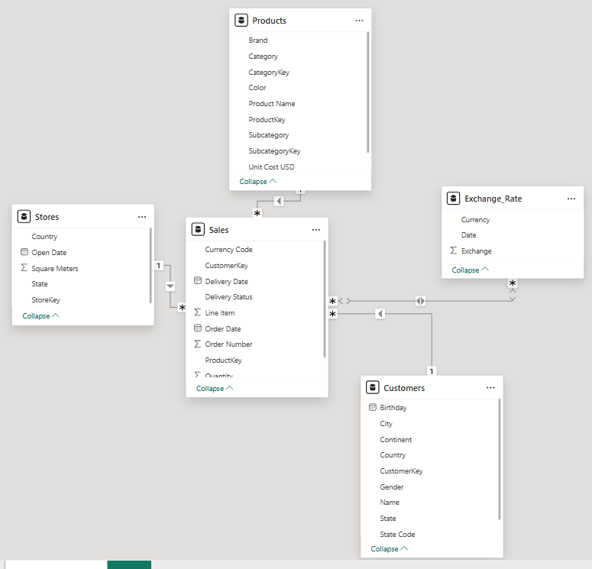

Dashboard Color Inspiration – TMP Mart (Techrity color), Purple shades (#EDE7F6,

Sales Analysis:

1. Total revenue – calculated using the DAX formula (SUMX(Sales, Sales[Quantity] *RELATED(Products[Unit Price USD])) and the result was 55.8million.
2. Total Sales order – 26326 distinct sales order was made.
3. Average Order made – 1,430,904.9 orders
4. Total no. of stores that made a sale – 58 out of 67 stores (Used count distinct function on the store key column)
5. Total Sold Quantity – 197,757. (Sum Quantity column in Sales table)
6. Total number of customers that made a purchase: 11,887 out of 15266 customers. (Used the count distinct function on the customer key column)
7. Total no. of sold products – 2492 out of 2517 products were sold. (Used count distinct function on the Product key column)
8. Total number of Line Item – 7.
9. Monthly Sales Trend – Generally, December had the peak sales with over 3635 orders as against April which had the lowest sales with 265 orders.
10. Yearly sales trend – This was derived using the filter panel for 2016 to 2021.

|  |  |  |
| --- | --- | --- |
| Year | Peak Month | Lowest Month |
| 2016 | December – 429 Orders | April- 41 Orders |
| 2017 | December – 549 Orders | April- 26 Orders |
| 2018 | December – 1089 Orders | April- 43 Orders |
| 2019 | December – 1250 Orders | April- 75 Orders |
| 2020 | February – 1124 Orders | April- 80 Orders |
| 2021 | January – 256 Orders | February – 242 Orders |

N/B: In 2021 sales was made for only two (2) months – January and February.

1. Best-selling products across stores – Created a new measure to calculate the total quantity sold “Total_QTY_Sold = SUM(Sales[Quantity])”. I used sort and filter to get the top 10 products sold. Which is shown below:

|  |  |  |
| --- | --- | --- |
| Product Key | Product Name | Total QTY Sold |
| 444 | WWI Desktop PC2.33 X2330 Black | 550 |
| 458 | WWI Desktop PC1.80 E1800 White | 538 |
| 424 | Adventure Works Desktop PC1.60 ED160 Black | 521 |
| 434 | Adventure Works Desktop PC2.30 MD230 White | 521 |
| 425 | Adventure Works Desktop PC1.80 ED180 Black | 520 |
| 423 | Adventure Works Desktop PC2.30 MD230 Black | 514 |
| 446 | WWI Desktop PC1.60 E1600 Black | 509 |
| 440 | WWI Desktop PC1.60 E1600 Silver | 507 |
| 435 | Adventure Works Desktop PC1.60 ED160 White | 505 |
| 452 | WWI Desktop PC1.60 E1600 Red | 505 |
| 448 | WWI Desktop PC1.80 E1801 Black | 505 |

1. Top 5 performing customers by order – Gaspare Trevisan (124 qty sold with 22.14%), Fabrice Lamoureux (123 qty sold with 21.96%), Vanessa Holzman (107 qty sold with 19.11%), Martha Thornton (103 qty sold with 18.39%), Richard Smith (103 qty sold with 18.39%).
2. Most used currencies – USD (106,407 – 53.81%), EUR (40,050 – 20.25%), GBP (25298 – 12.79%), CAD (16793 – 8.49%), AUD (9209 – 4.66%).
3. Seasonal Spikes or dips in product demands – Order Year and Count Distinct of Order Number in a line graph. Results: 2021 – 498, 2020 – 4635, 2019 – 9083, 2018 – 5965, 2017 – 3280, 2016 – 2865. Seasonal Spike was in 2019.
4. Top 5 Performing Stores and their States – Results shown below

|  |  |  |
| --- | --- | --- |
| Store Key | State | Total QTY Sold |
| 0 | Online | 41311 |
| 9 | NorthWest Territories | 4894 |
| 55 | Nevada | 4826 |
| 50 | Kansus | 4773 |
| 61 | South Carolina | 4771 |

The top performing stores across years and months can be seen with the filter panel for the year.

1. Delivery Status of orders - delivered orders were 13,165 (20.94%) and not delivered orders were 49,719 (79.08%).
2. Item Visibility – The visibility of item by store using the line-item column shows the following: Line 1 – 82695 quantities sold, Line 2 – 52579 quantities sold, Line 3 – 32387 quantities sold, Line 4 – 16256 quantities sold, Line 5 – 6979 quantities sold, Line 6 – 4549 quantities sold, Line 7 – 2312 quantities sold.

Product Performance:

1. KPI’s – No. of Products = 251; No. of Brands = 11; No. of Colors = 16; No. of Category = 8; No. of Subcategory = 32; Total Unit Cost = $371649.05; Total Unit Profit = $898141; Total Profit = $526492.
2. Brands with the highest product margin and quantity sold – Bar charts were used to represent the profits made by each brand and the results are shown below:

Contoso – $118334.02/49827 qty sold

Fabrikam – $99191.94/11384 qty sold

Litroare – $73542.55/5309 qty sold

Adventure works – $59168.82/20099 qty sold

Prose ware – $46272.77/9427 qty sold

Wide World Importers – $41741.56/27413 qty sold

The Phone Company – $24710.39/18764 qty sold

Northwind Traders – $21539.21/7610 qty sold

A.Datum – $20754.17/20754.17 qty sold

Southridge Video – $17477.55/24814 qty sold

Tailspin Toys – $3759.41/17455 qty sold

1. Profits by product categories – Home Appliances (206386.69); Computers (119726.74); Cameras & Camcoders (89885.16); TV and Video (63403.27); Cell Phones (28229.14); Audio (9058.92); Music, Movies & Audio books (5943.50); Games & Toys (3859.17).
2. The product category that performs best in terms of revenue is Home Appliances.
3. Product categories by volume – Volume was measured by quantity sold. Home Appliances (18401); Computers (44151); Cameras & Camcoders (17609); TV and Video (11236); Cell Phones (31477); Audio (23490); Music, Movies & Audio books (28802); Games & Toys (22591).
4. Top 5 performing product – This was calculated based on product with the highest revenue. They are: Fabrikam Refrigerator 24.7CuFt X9800 Blue ($2139.77), Fabrikam Refrigerator 24.7CuFt X9800 Brown ($2139.77), Fabrikam Refrigerator 24.7CuFt X9800 Green ($2139.77), Fabrikam Refrigerator 24.7CuFt X9800 Grey ($2139.77), Fabrikam Refrigerator 24.7CuFt X9800 Orange ($2139.77).
5. Effect of product’s color on Profit and Sales – Black (52389 qty sold/$105921.56), Silver (37535 qty sold/$94375.36), White (36382 qty sold/$108999.89), Grey (14874 qty sold/$48849.55), Red (12022 qty sold/$18461.72), Blue (11814 qty sold/$49162.71), Pink (6335 qty sold/$13626.82), Brown (6239 qty sold/$26549.40), Gold (6028 qty sold/$8405.38), Yellow (5196 qty sold/$1740.19), Green (4092 qty sold/$28750.06), Orange (2407 qty sold/$16009.57), Purple (966 qty sold/$268.69), Azure (640 qty sold/$1655.10), Silver Grey (625 qty sold/$3714.95), Transparent (213 qty sold/$1.44).
6. Revenue by delivery status – Delivered goods had $526492.39 (50%) revenue and Not delivered goods had $526492.39 (50%) revenue.
7. Top 7 subcategory Revenue and Sales – Washers & Dryers ($7145320/1180 qty sold), Projectors & Screens ($47840/4757 qty sold), Camcorders ($46615.70/4482 qty sold), Refrigerators ($46106.97/2324 qty sold), Laptops ($28940.88/4947 qty sold), Home Theater System ($27920.18/1375 qty sold), Digital SLR Cameras ($27727/4308 qty sold).

Customer Insights:

1. KPI’s – Total no. of Customers (15,266), No. of city (8258), No. of State (512), No. of Country (8), No. of the Continent (3), Minimum birthyear (1935), Maximum birthyear (2002), Average Age (56.8 years old)
2. Grouped the customers age into the following – Gen Z (20-30), Millinials(31-40), Gen Y (41-50), Gen X (51-60), Babyboomer (61-70), Silent generation (71-80), Older Silent generation (81-90).
3. The age and gender distribution of customers are shown below:

|  |  |  |  |
| --- | --- | --- | --- |
| Age Group | Male | Female | Total |
| Babyboomers | 1167 | 1169 | 2336 |
| Silent Generation | 1144 | 1140 | 2284 |
| Gen Y | 1123 | 1148 | 2271 |
| Millinials | 1170 | 1098 | 2268 |
| Gen X | 1163 | 1096 | 2259 |
| Older silent generation | 1128 | 1065 | 2193 |
| Gen Z | 853 | 803 | 1656 |

1. Revenue by country – United States ($29.9m), United Kingdom ($7.1m), Germany ($5.4m), Canada ($4.7m), Australia ($2.8m), Italy ($2.5m), Netherlands ($1.98m), France ($1.5m).
2. Top 5 states of customer residence by revenue – California ($3.1m), Texas ($2.3m), Ontario ($1.98m), New York ($1.7m), Freistaat Bayern ($1.56m).
3. Top 5 city of customer residence by revenue – Toronto ($601k), Newyork ($492k), Los Angeles ($468k), Philadelphia ($379k), Houston ($367k).
4. Top 5 customers by purchase frequency – Gaspare Trevisan (23.73%), Delmer Martinez (20.34%), Donald Williams (18.64%), Katherine Rosales (18.64%), Richard Smith (18.64%).
5. Customer demographics by sales – North America (123200 qty sold), Europe (65348 qty sold), Australia (9209 qty sold).
6. Revenue by continent – North America ($35.6m), Europe ($18.5m), Australia ($2.7m)
7. Age distribution by Revenue -

|  |
| --- |
| Babyboomers – 8.23million |
| Silent Generation – 8.31million |
| Gen Y – 8.20million |
| Millinials – 8.60million |
| Gen X – 8.30million |
| Older silent generation – 8.05 million |
| Gen Z – 6.06million |

1. Top 5 Customers by revenue – Matthew Flemming (61871k), Stephan Rothstein (45608k), Karen Jones (43517k), Zrina Topic (42788k), Stefanie Hartman (41521k).
2. Gender by Revenue – Male (101941k), Female(16479k).

Store Benchmarking:

1. KPI’s – No. of Stores (67), No. of Country (9), No. of state (67), total store square meter (92.5k), Average store age (13.9 years), No. of top store by country (2), Revenue by square meter (26.5k/sqm), quantity per square meter (93.9 sqm).
2. Total Revenue by Country – Online stores ($11.4m), United States stores ($4.2m), Canada stores ($1.4m).
3. Total Revenue by store states - Online ($11.4m), Nevada ($1.42m), Kansas ($1.39m), Nebraska ($1.38m), Northwest Territories ($1.34m).
4. Top 5 store keys by revenue and stores – Store key 9, store key 55, store key 50, store key 54.
5. Average Store Age by demographics – Canada (20yrs), Online (15yrs), United States (15yrs).
6. Average store age by demographics – Northwest Territories (20yrs), Kansas (17yrs), Nevada (16yrs), Online (15yrs), Nebraska (12yrs).
7. Store age by Revenue – 15years ($11.40m), 16years ($1.42m), 17years ($1.39m), 12years ($1.38m), 20years ($1.34m).
8. Total Order by Location – Online stores (68.94%), Northwest Territories (8.13%), Nebraska (7.77%), Nevada (7.68%), Kansas (7.47%).
9. Store Category by Revenue – The store sqm was grouped into Large, medium and small and categorized based on their revenue and number of stores. Large stores were 52 and generated $39.66m, Medium stores were 6 and generated $3.18m while small stores were 9 and generated $12.91m.
10. Concentration of Top Stores by Region shows the greater concentration around Nunavut.